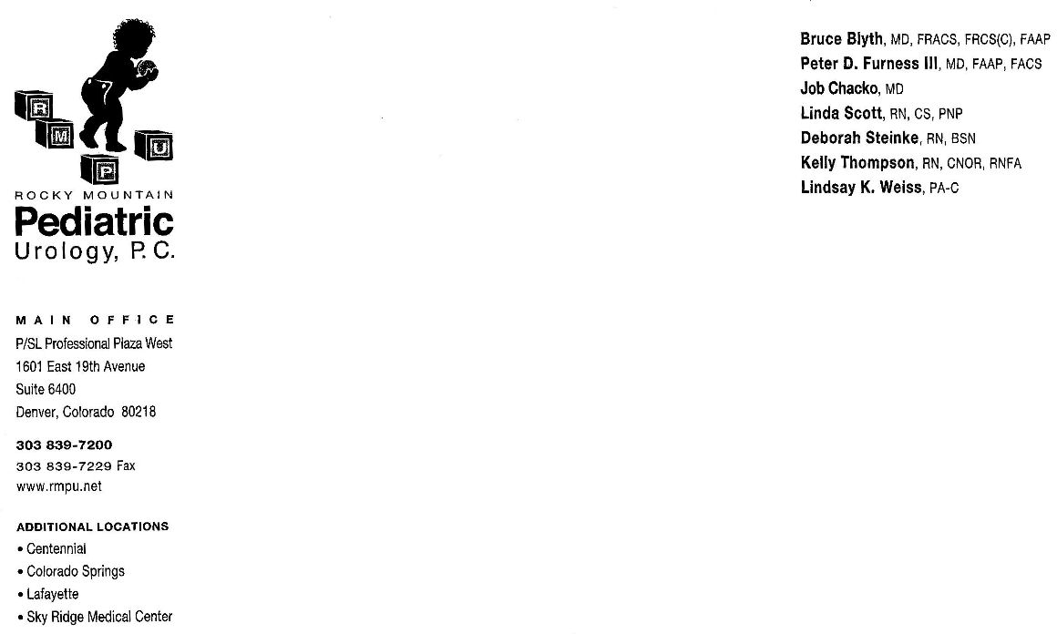

CIRCUMCISION

Circumcision is an operation in which the foreskin that covers the top of the penis is removed.

OPERATION:

A circumcision takes about 30 to 60 minutes in the operating room. General anesthesia is used. Your child will go home with a dressing on his penis. He will be allowed to bathe/shower in about 2 days. The dressing will remain in place for 2-5 days. The stitches will dissolve on their own in a few weeks. There are some children who react to what the stitches are made of, and some redness around the stitches may be noted during the second and third week. Because the foreskin may need to be separated from the head of the penis during the circumcision, the head of the penis may appear red and look like it has been scraped. A scab may form and heal over 2 weeks. This is normal and will resolve on its own.

POST-OPERATIVE CARE (Care of the child after the operation):
After surgery, start with clear liquids (apple juice, broth, popsicles, Jell-O, iced tea, water, Kool-Aid) at home and advance to a normal diet if he is able to keep the fluids down and does not vomit (throw up). Advance slowly and in small amounts. There may be some throwing up from the anesthesia. Most of the time this stops by the next morning. If severe nausea (a sick feeling in the stomach) and vomiting (throwing up) occur and your child is unable to keep fluids down, please call the doctor.

Activity:
The day of surgery should be a quiet day. Most often, the child sets the pace of going back to normal activities. The main concern is to protect the site of surgery. Riding toys, rough play or any activity that could injure the surgical site should be avoided for 2 weeks.

Pain Management:
Your child may be given some pain medicine in the recovery room and you will be told when you can safely give a dose. You will receive instructions on time, amount and how often to give the medicine. Usually, only Tylenol and Ibuprofen are given. Occasionally, Tylenol with Codeine is used also. Young babies and children may be fussy and restless and this may be the only sign of pain. Give your child Tylenol and see if this helps. Also, when he takes a nap or goes to bed at night, pain medicine may be a good idea. Remember to follow instructions on the amount and how often the medicine should be given. If your child is unable to be calmed after you have tried all comfort measures and given medicine, please call the doctor.

Incision Care:
Please keep the incision clean. The penis will be covered with a dressing when he returns from the operating room. You will be told to leave the dressing in place and that the dressing should be removed in 2-5 days. Bathing or taking a shower is allowed 2 days after the operation. Sponge bath is allowed the first 2 days. Remember that the stitches will dissolve and will go away on their own. After the dressing is off, push down at the base of the penis and apply the antibiotic ointment first until the tube is finished, then switch to Vaseline or A&D ointment to the incision line until seen again in clinic. If drainage (pus) or bleeding occurs, call the doctor. The type of bleeding to be concerned about is bleeding that won't stop after gentle pressure has been applied. This type of bleeding may occur in the first 24 hours and the doctor needs to be called. Another type of bleeding that occurs is from the abrasion (looks like a scrape). As the scab is healing, the scab may fall off and cause minor bleeding. It should stop bleeding within a short period of time. After the dressing comes off, apply ointment generously to prevent drying and chafing.

FOLLOW-UP VISIT:

Post-operative follow-up will be a clinic appointment in 5-6 weeks. You may call the office at 303-839-7200 to schedule an appointment. Post-operative appointments may be made at any of the clinics. Dr. Chacko sees patients at Lafayette, Aurora, Denver and Colorado Springs.

Call the doctor if:

-Temperature is greater than 101.0 F or 38.5 C,
-Drainage (pus) at the operation site.
-Child is unable to be comforted even after all comfort measures have been used and pain medicine has been given.
-Vomiting after the first day of surgery and the child is unable to keep fluids down.
-Bleeding occurs during the first 24 hours and cannot be stopped after gentle pressure has been applied.

If you have any questions or concerns, please call the urology nurse between 8:00 a.m. and 4:30 p.m. at 303-839-7200. To call the doctor about a problem: Call the office at the main number during evenings, nights and weekends to speak with the doctor on call.

