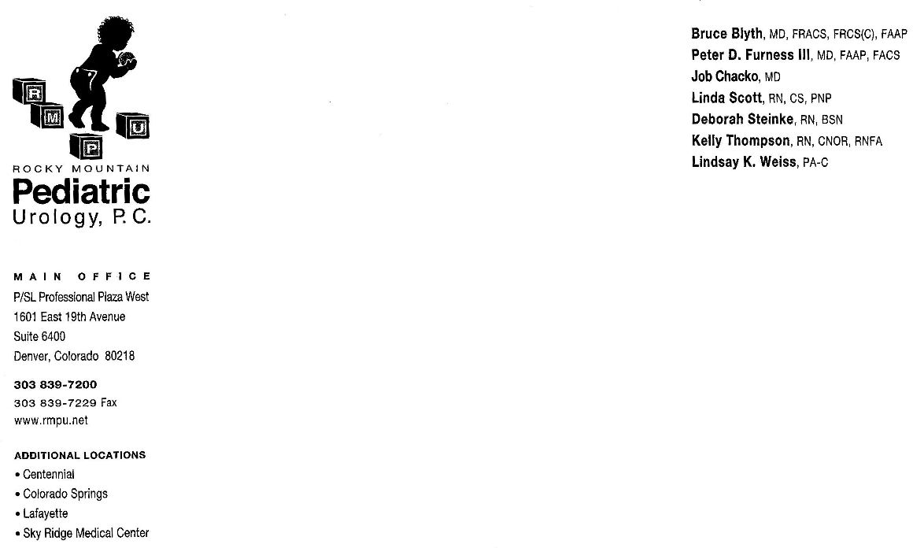

Rocky Mountain Pediatric Urology
Dr. Chacko

Hernia and Hydrocele

In normal testicular development, the testicle travels through the abdomen into the scrotum during the 3rd trimester. Typically the tunnel from the abdomen to the scrotum (the processus vaginalis) closes before birth or during the first year of life. However, it is not uncommon for the tunnel to remain open allowing fluid or bowel to enter. When this happens it is called a communicating hydrocele or hernia. Inguinal hernias occur in up to 4% of children and 30% of premature infants. Hernias are nine times more common in boys and are most commonly (60%) found on the right side.

When there is only fluid in the scrotum with no connection to the abdomen, it is called a hydrocele. This should resolve within one year. If a hydrocele gets larger (instead of smaller), causes pain or discomfort and persists beyond the first year of life, surgical intervention is necessary. When bowel gets down into the inguinal canal or scrotum it is called a hernia. If this causes discomfort, becomes red and hard, or makes the child ill (vomiting, nausea, fevers), surgical intervention may be necessary.

Surgical repair

The surgery involves very small incisions in the inguinal canal and/or the scrotum. Sometimes it is necessary to do this on both sides if there is a concern that an opening exists on the other side as well. It is not uncommon for the surgeon to make a small incision in the belly-button (umbilicus) in order to use a scope to look at the hernia/s. The procedure is performed in Day Surgery, which means that your child should be able to go home after surgery once he is stable.

Post-operative care

Activity Your child needs to be kept quiet and under supervision for 24 hours after surgery. Avoid straddle toys (tricycles, rocking horse, trampoline, etc.) for two weeks after surgery. Your child may return to school/daycare in 2-3 days if adequate supervision is available. No sports/gym for up to one month. It is important to avoid any injuries to the area. When lifting your child, support his buttocks to prevent strain at the surgery site.

Surgical Site There is no special care for the incision. There may be a small incision made in the belly button. This will be covered with Steri-Strips (which hold the skin together like a stitch), a cotton roll, and a clear plastic dressing. The groin incision will have Steri-strips and a clear, flexible dressing. Leave the surgical tape or dressing alone until it comes off by itself. If it is still on 2 weeks after surgery, you may remove it yourself.

Bathing It is okay to bathe your child 2 days after surgery. A warm bath without soap will help reduce swelling and discomfort. Change diapers frequently to keep the incision site clean.

Bruising You can expect bruising or swelling of the scrotum. This should resolve over the next few weeks.

Diet Start with clear liquids. When clears are tolerated without vomiting, you may advance to regular foods.

Pain Relief We recommend alternating Tylenol or Ibuprofen every 4 hours for the first few days after surgery. Follow directions given by the nurse in the discharge area the day of surgery.

Follow-up Appointment
Post-operative follow-up will be a clinic appointment in 4-6 weeks. You may call the office at 303-839-7200 to schedule an appointment. Post-operative appointments may be made at any of the clinics. Dr. Chacko sees patients at Lafayette, Aurora, Denver and Colorado Springs.

