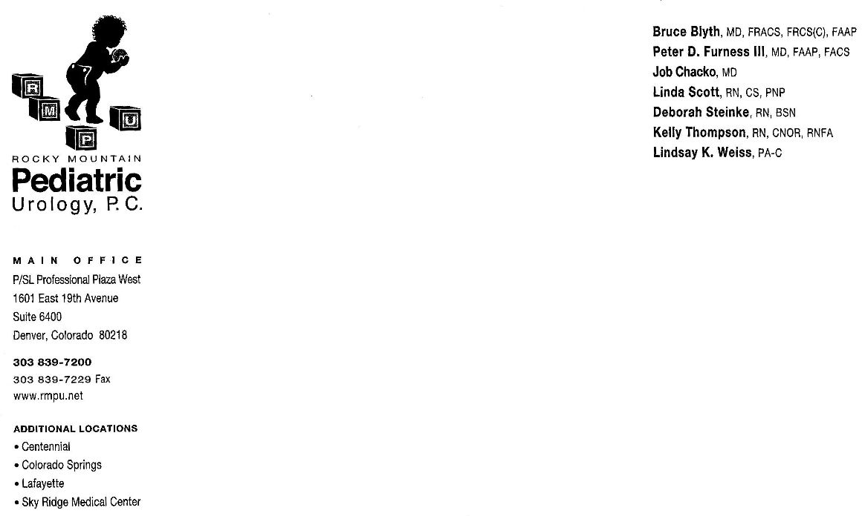

Rocky Mountain Pediatric Urology
Dr. Chacko

Undescended Testicle

The testicles are egg-shaped organs that lie in the scrotum. As an adult, the testicle tissue produces the male hormone testosterone and the reproductive cells called sperm. An undescended testicle occurs when there is failure of the testicle to descend from the abdominal position into the scrotum during development.

There are multiple reasons the testicle needs to be in the scrotum. The scrotum keeps the testicles several degrees cooler than the core body temperature. This lower temperature is important for the development and production of fertile sperm in the future. A testicle that is not in the scrotum cannot be physically examined. An undescended testicle is at a low but increased risk for testicular cancer. This type of cancer is highly curable when found early. The best way to find this type of cancer is with examination. This is possible only when the testicle is in the scrotum. A scrotum containing two testicles appears physically normal.

Surgical Repair

Orchiopexy is the name of the surgical procedure when the testicle is brought down into the scrotum. A small incision is made in the groin and the scrotum. The testicle is brought down to the scrotum and fixed in place. A hernia sac is also associated with the undescended testicle and is repaired at the same time. Occasionally, a laparoscopic incision and/or a second procedure may be necessary if the testicle is high up in the abdomen. Laparoscopy is the use of a small telescope to help locate a testicle that is undescended and high in the abdomen. A laparoscopic technique may used to bring the testicle down into the scrotum. In some cases the testicle might be abnormal and need to be removed. The procedure will last approximately 1 hour.

Post-operative care

Activity Your child’s activity should be limited for 24 hours after
surgery. Avoid straddle toys (tricycles, rocking horse, trampoline, etc.) for two weeks after surgery. Your child may return to school/daycare in 2-3 days if adequate supervision is available. No sports/gym for up to one month. It is important to avoid any injuries to the area. When lifting your child, support his buttocks to prevent undo strain at the surgery site.

Surgical Site There is no special care for the incision. Leave the surgical dressing
or tape in place until it comes off by itself. If still in place 2 weeks
after surgery, you may remove the dressing. The stitches are are dissolvable and will get reabsorbed by the body.

Bathing It is okay to bathe your son 2 days after surgery. Sponge bath the first 2 days.

Bruising/swelling You can expect bruising or swelling of the scrotum. This may appear
appear a day or so later and should resolve over the next few weeks.

Diet Start with clear liquids. When clears are tolerated you may advance to regular foods.

Pain Relief We recommend alternating Tylenol and Ibuprofen every 4 hours for the first few days after surgery. Occasionally, Tylenol with codeine is needed. Please follow discharge instructions given the day of surgery.

Follow-up Appointment

Post-operative follow-up will be a clinic appointment in 4-6 weeks. You may call the office at 303-839-7200 to schedule an appointment. Post-operative appointments may be made at any of the clinics. Dr. Chacko sees patients at Lafayette, Aurora, Denver and Colorado Springs.

