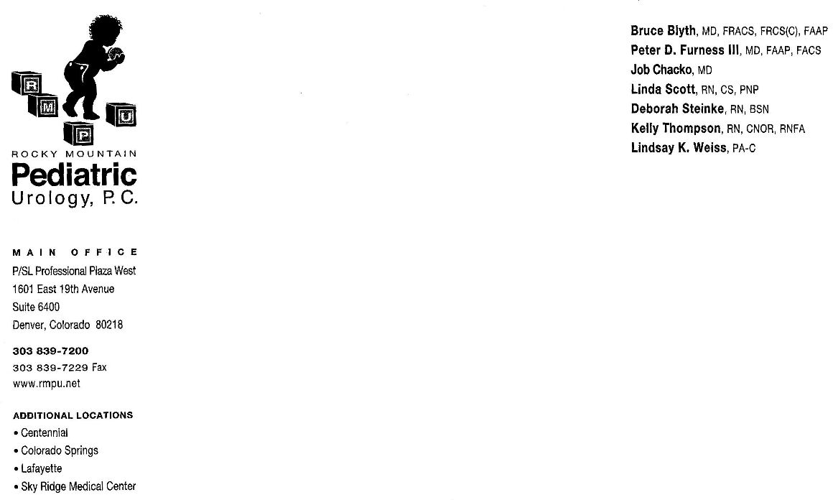

Rocky Mountain Pediatric Urology
Dr. Chacko

CARE OF THE CHILD AFTER A
URETHROMEATOPLASTY

Meatal Stenosis is a narrowing of the meatus (opening) at the tip of the penis. This is seen almost exclusively in circumcised boys, and is secondary to irritation of the tip from diapers. Symptoms of meatal stenosis can be an upward deflection of the urinary stream, difficulty aiming the stream, a narrow stream, blood at the tip to the penis, or straining with urination. Occassionally, the child will experience burning with urination, frequency, urgency, and prolonged urination.

Surgical Procedure: This procedure takes approximately 30 minutes and is done under a general anesthesia. This is done as a day surgery procedure and the child will be able to go home on the same day as the surgery. It involves widening the meatus (opening) to improve the urinary stream

Stitches and Dressings: Dissolvable stitches will be placed to widen the opening. These will dissolve in 7-10 days. No dressing will be placed. You will be asked to apply antibiotic ointment to the tip of the penis after each use of the bathroom or as often as 10 times per day. Please use this ointment for 14 days after surgery.

Appearance: The tip of the penis may be red and the lips of the meatus may swell. This will resolve in about one week. You may see a few drops of blood from the end of the penis. This is normal. You may notice a “spraying” effect when your child urinates. This spraying will resolve once the stitches dissolve in about 7-10 days after surgery.

Pain: There may be some mild discomfort when your son first urinates after this surgery. You may place your child in a warm bath if he is hesitant to pee. You should give Tylenol and Motrin 4 times a day in alternating doses for 36 hours.

Bathing: Your son may have a bath or shower the day after surgery. Swimming is okay 3 days after surgery.

Follow-up appointment: Call the office to schedule an appointment for 6 weeks after surgery at 303-839-7200.

