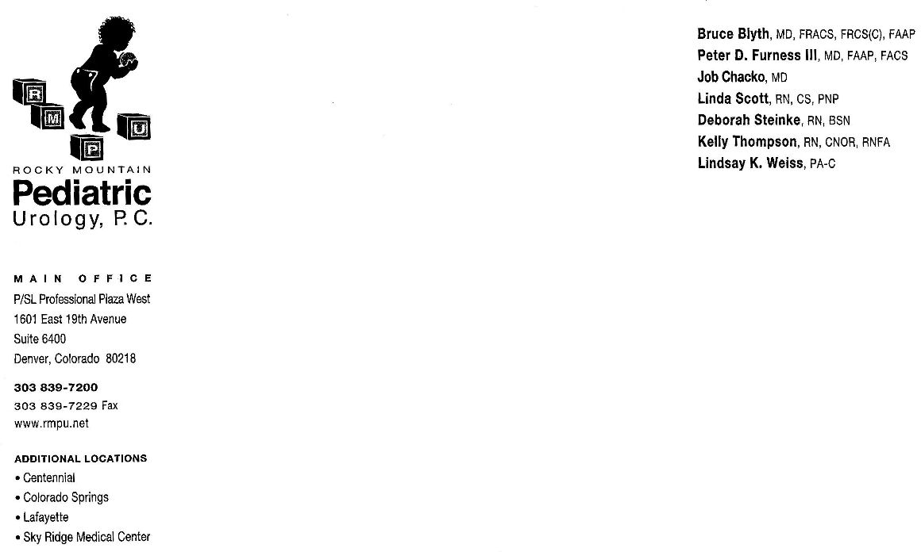

Rocky Mountain Pediatric Urology
Dr. Chacko

Varicocele

A varicocele is an abnormality in the veins of the spermatic cord that support the testicles. The valves in these vessels are incompetent, preventing the normal flow of circulation allowing blood to back up in the veins leading to dilation (swelling). This is similar to the varicose veins that develop in legs, only this is around the testicles.

The incidence of varicoceles is rare prior to puberty but increases to about 15% in adolescent males and adulthood. They are graded in size on a scale of I-III with grade III being the largest. The majority of varicoceles occur on the left side due to the angle of the vessels as they enter the renal vein. 1-2% of varicoceles may occur on both sides. Varicoceles generally develop slowly over a period of time and are typically painless. A varicocele is often compared to feeling like a ‘bag of worms’ and it is not uncommon for it to be first detected by the patient himself.

In 80% of the cases of large varicoceles the affected testis and some times the opposite testis may show signs of growth retardation (hindered growth). When there is a grade III varicocele particularly when there is testicular size discrepancy surgical repair is strong consideration to help restore normal testicular volume. The concern with growth retardation of a testicle is that the potential of that testis, as well as the opposite testicle, may not develop to its full potential with regard to fertility. There is an association between adult fertility and varicoceles. 40% of the infertile adult population has a varicocele as compared to only 15% of the normal population. Surgery is 80% successful in restoring testicle size and theoretically improving potential infertility problems.

Surgery
The surgical procedure for a varicocele is called a varicocelectomy. This is the ligation or interruption of dilated veins. There are several different surgical procedure options which include 1) laparoscopic 2)open surgical and 3) radiologic embolization.

Laparoscopy involves using a scope through the abdomen to ligate the abnormal vessels. It takes approximately 1.5 hours in Outpatient Day Surgery. Your child will go home several hours after the procedure. Post-operatively your child will resume normal activity within 7-10 days after surgery.

The ‘open’ procedure involves a surgical incision (~1 inch) being made in the groin area and will also take about 1 hour in Outpatient Day Surgery. Your child will go home several hours after the procedure. Your child will feel well enough for normal activity in 2-3 days but should wait about 1 week after surgery before resuming normal daily activities.

Radiologic embolization is done in the department of Radiology and may take about 3 hours. The large blood vessel of the leg is accessed (similar to a heart catheterization) with a long catheter and a substance is injected to clog the abnormal veins. Post -operative recovery is variable but normal activity is usually resume with in 24-72 hours.

Post-operative follow-up is a clinic visit 6-8 weeks after surgery. You may call the office at 303-839-7200 for an appointment.

